# R&D Project Portfolio System Stakeholder

**Background:**

Leanne Bint is the External Relations & Development Co-ordinator of the project portfolio. Her role is to communicate with potential industry and convince them to offer projects that students can work on.

**Other Team Member:**

Jackie, Ramesh, Tanya

**Suggestions for projects**

Leanne Bint think it's really important for you as working on this project

is to understand that the technical part of it is one part of it, but the communication and the relationships is a big part of it

**Challenges of job:**

1. Talk to all the industry people who support these students, industry is giving resources and time to the student teams. industry don't hear regularly from students or the students don't keep in contact or whatever, industry become very unhappy. If something goes wrong with the student team and industry that will be the first challenge. Build relationships with clients.
2. Balancing students starting students finishing, balancing looking for projects in semester one, looking for projects in semester two.  
   students studying projects in both Semester 1 and Semester 2. This results in two separate cohorts of students: those who start and finish their projects in Semester 1 and those who start in Semester 2.

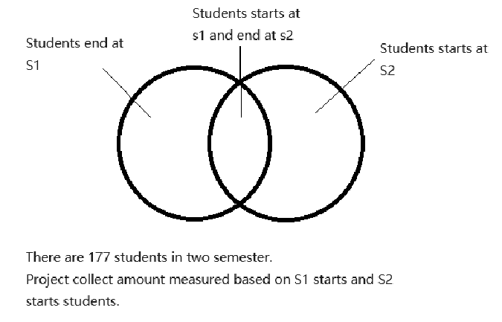

**Process of Project Portfolio Management:**

Searches for projects discussion with industry

Industry submits project via email

Shares project with academic headers

Headers assess suitability of project

Yes No

SharePoint

Form gets sent to students

Student choose

Academic sort out choices

**Automated collection projects can’t achieve:**

1. Collection projects must communicate.

Make meeting with industry because you need to tell them what it is, what you want them to do. After they will talk to their work colleagues and discuss, then come back and manage time to meet.

While received project, Leanne Bint needs to talk to team member and discuss the project whether it’s suitable or not suitable. If not suitable it has to go in this pile and keep looking until enough projects for all students. Overall, it’s all about lots of meeting and lots of conversations.

1. Information evaluation

It’s a matter of absorbing the information, need to read and understand, its not just computer thing. Some items are suitable but not suitable for students. For example, received a project from hospital but it provides real data, that will be not suitable for students to work on because its private data.